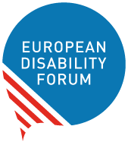

Communications Checklist:
Making campaign communications accessible for persons with disabilities
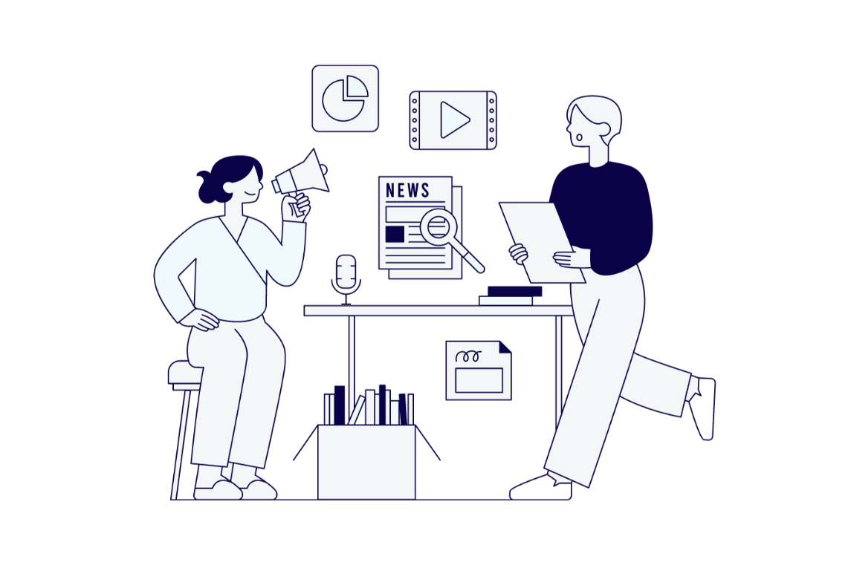

Funded by the European Union. Views and opinions expressed are however those of the author(s) only and do not necessarily reflect those of the European Union. Neither the European Union nor the granting authority can be held responsible for them.

Table of Contents

Introduction 3
Alternative formats 4
Images 4
Learn 4
Written content and Web articles 5
Learn 5
Social media 6
Learn 6
Leaflets, manifestos and other written material 7
Videos 8
Learn 8
Podcasts/audio 7
Website 9
Learn 9
Tools 10
Useful contacts 10
Scoring 11
Alternative format section 11
Images 11
Written content and Web articles 11
Social media 12
Leaflets, manifestos and other written material 12
Videos 12
Podcasts/audio 13
Website 13
Results 13
From 0 to 30 points: campaign intern 14
From 30 to 90 points: campaign staffer 14
From 90 to 113 points: Senior Advisor 14
From 113 to 126 points: Chief of Staff 14
Document credits 15

Introduction
Over 87 million persons with disabilities live in the European Union. However, most election campaigns still do not consider their accessibility needs.
Persons with disabilities are deprived of their right to stand as a candidate and to cast an informed vote due to accessibility barriers in all parts of the electoral process – including in accessing information about political and electoral campaigns.
This checklist is intended to provide persons working in elections and political campaigns with an easy-to-check and implement process to ensure that their messages will reach persons with disabilities.
The checklist is divided into sections corresponding to different formats and means of communication. This way, the reader can easily take steps to ensure their materials can be accessed and understood by everyone.
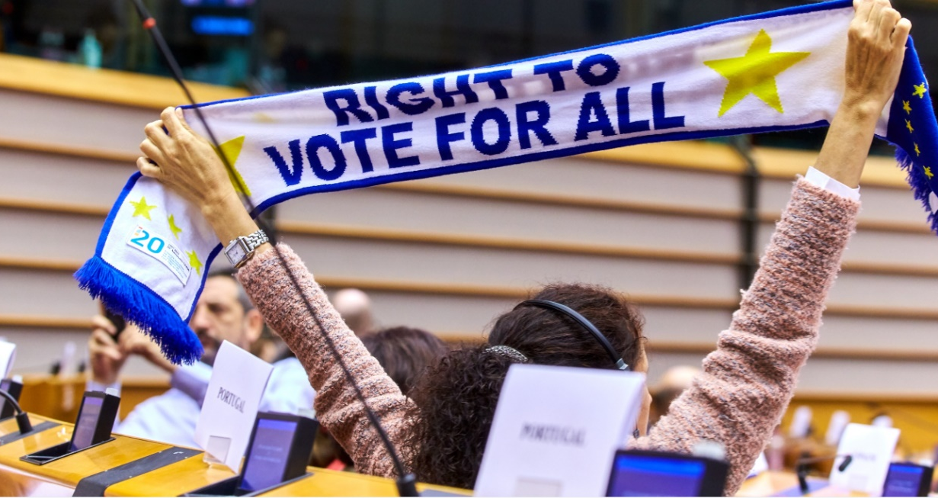

Everyone has the right to an informed vote

Alternative formats
- ☐ I always provide the most important information (manifesto, speeches, candidate lists, for example) in more than one format (a PDF and an online article, Word or other formats, a video and article, or online and in a written physical document, etc.)

Images
- ☐ I write alternative text to my images or mark them as decorative.
- ☐ If my image has important text, I make the text accessible in other formats (link to website, copied in the document).
- ☐ I ensure that my images have good colour contrast.
- ☐ When my image conveys an important message, I don’t use only colour to convey it.

Learn
- Alternative text: a written description of visual content. Alternative text should be brief and convey the most important messages and visual elements of the image. Learn how to write alternative text.
- Colour contrast: There are many online tools to check colour contrast. A widely used, free tool is the Colour Contrast Analyzer.

Written content and Web articles
- ☐ I use almost no acronyms, and if I do, I explain them.
- ☐ I use common words in my articles.
- ☐ My font size is bigger than 12, or it is easy to zoom in.
- ☐ I use sans-serif fonts (Arial, Verdana).
- ☐ I do not use italics.
- ☐ If I use complex words, I explain them.
- ☐ I mostly keep my sentences to 25 words.
- ☐ I use descriptive link text - I add links directly into words to create clickable text instead of adding the URL separately. ( Do: European Disability Forum; Don’t: https://www.edf-feph.org/ )
- ☐ My linked text is descriptive and I avoid words like “Click here” or “Link here”.
- ☐ I do not use different colours in the text body.
- ☐ The colour of my text has enough contrast (at least (4.5:1)..
- ☐ I provide easy-to-read versions of my most important documents.
- ☐ In documents: I use the built-in tools for making headings, instead of manually (selecting text and increasing font or putting it in bold every time I want to do a heading).
- ☐ In Microsoft Word software: I use the built-in accessibility checker to review the accessibility of my document.

Learn
- It is recommended to keep sentences to 25 words. Learn about plain language.
- Easy-to-read is a method to make information accessible to people with intellectual disabilities.
- Software to write text (like Microsoft Word) has tools to format styles and headings. This allows persons who use screen readers or other technologies(software that reads words on screen) to understand the format of the document. Learn how to do headings and styles.
- Microsoft office programs have a tool called accessibility checker. It cannot check all accessibility, but it is very helpful for making your documents more accessible.
- Daisy Consortium has a tool called WordtoEPUB that helps covert documents to accessible E-pubs

Social media
Most platforms are not fully accessible. However, users of the platform can take some actions to make their content more accessible:
- ☐ I am using simple words on my posts.
- ☐ I am not using “fancy text”: Unicode characters, ASCII or tools to make different fonts.
- ☐ I am not using italics.
- ☐ I am capitalising the first letter of each word when doing hashtags (Example: #AccessibilityIsGood and not #accessibilityisgood)
- ☐ I am not using too many hashtags
- ☐ I am limiting the use of emojis (maximum 2 or 3)
- ☐ I am not using emojis to replace text.
- ☐ I am not using animation or GIFs with blinking images or lights
- ☐ I use descriptive calls to action (Read the interview; Download the document; etc)
- ☐ I am adding alternative text/image descriptions to my posts for images and GIFs.
- ☐ I am captioning my videos using the native closed captions tools.
- ☐ My videos have interpretation in sign language.

Learn
- How to add alternative text to social media platforms.
- The Accessible Social website has many useful tips.

Leaflets, manifestos and other printed material
- ☐I always provide an accessible online version of my material – including an online version directly in HTML.
- ☐ I make available versions in braille and large print.
- ☐ I have QR codes that direct to an online accessible version.
- ☐ The colours of my materials provide good contrast (at least (4.5:1)..

Podcasts/audio
- ☐ I provide a transcript of my audio content.
- ☐ The guests and presenters of my podcast speak slowly.
- ☐ If I have person speaking and background music, the music is at least 20 decibels lower.

Videos
- ☐ I add captions to my video – through manually refining automatic captions or commissioning professional manual captions.
- ☐ I add sign language to my video.
- ☐ I provide a transcript.
- ☐ All written information is read aloud
- ☐ If there information on a different language, I provide a dubbed version.
- ☐ I provide an audio-described version if there are visual elements conveying meaning (e.g. written signs or speechless actions).
- ☐ If my video has text (that are not captions), I use a sans-serif font with size of, at least, 24.
- ☐ My video does not have flashing content.
- ☐ My video has generally good contrast between main subject and background (at least (4.5:1).
- ☐ If I have person speaking and background music, the music is at least 20 dB lower.

Learn
- The EDF guide for accessible video provides detailed explanation to make your video accessible.
- Audio-description: narration of meaningful visual information in a video. This includes identifying speakers, providing relevant context and describe significant visual elements.

Website
- ☐ I hire a provider with expertise on digital accessibility.
- I contract a digital accessibility professional or ensure my provider hires a digital accessibility professional for consultation and audits.
- ☐ I do not use overlays (or third-party tools that promise to make my website accessible “through AI”) as a means to make my website accessible.
- ☐ I use a mix of audio, video and text on my website.
- ☐ I separate the information with informative headings.
- ☐ My website has good contrast.
- ☐ I make sure persons can navigate my website only with keyboard.
- ☐ I make sure that links to other parts of the website are identified with more than just colour (underline, arrows)
- ☐ I do not have videos, audio or other content in autoplay.
- ☐ I do not have banners, images or other content that switch automatically.
- ☐ I use adequate labels for form fields, and my forms explicitly point errors when entered.
- ☐ I always use the built-in styles on my content management system (headings, quotes, adding videos, etc)
- ☐ My videos have captions.
- ☐ My website was verified by an accessibility specialist or organisation and passed the audit.

Learn
- The International Association of Accessibility Professionals has a list of certified professionals.
- W3Cx: Introduction to Web Accessibility
- Web Content Accessibility Guidelines

Tools
- ACE: the Accessible Colour Evaluator
- Colour Contrast Checker
- NoCofee Vision Simulator
- Web Accessibility Evaluation tool (download the browser extensions)
- Microsoft accessibility insights (Web)
- Button Contrast Checker
- Tingtun PDF checker
- Web Accessibility Initiative training Course
- AccessMonitor (Web)
- Colouring for Colourblindness
- Google Lighthouse

Useful contacts
If you need some useful contacts, EDF can support you.
E-mail: andre.felix@edf-feph.org

Scoring
When scoring, check each section. If you ticked the box, count the correspondent points below. The points represent a balance between their usefulness and difficult to implement.

Alternative format section
Number 1: 2 points
Total: /2

Images
Number 1: 2 points
Number 2: 3 points
Number 3: 1 point
Number 4: 2 points
Total: /8

Written content and Web articles
Number 1: 2 points
Number 2: 3 points
Number 3: 1 point
Number 4: 2 points
Number 5: 1 point
Number 6: 2 points
Number 7: 3 points
Number 8: 1 point
Number 9: 2 points
Number 10: 1 point
Number 11: 1 point
Number 12: 3 points
Number 13: 2 points
Number 14: 3 points
Total: /27

Social media
Number 1: 2 points
Number 2: 1 point
Number 3: 2 points
Number 4: 2 points
Number 5: 1 point
Number 6: 1 point
Number 7: 1 point
Number 8: 2 points
Number 9: 1 point
Number 10: 2 points
Number 11: 3 points
Number 12: 3 points
Total: /21

Leaflets, manifestos and other written material
Number 1: 2 points
Number 2: 3 points
Number 3: 1 point
Number 4: 2 points
Total: / 8

Videos
Number 1 : 3 points
Number 2 : 3 points
Number 3 : 2 points
Number 4 : 3 points
Number 5: 2 points
Number 6: 3 points
Number 7: 2 points
Number 8: 2 points
Total: / 20

Podcasts/audio
Number 1: 2 points
Number 2: 3 points
Number 3: 2 points
Total: / 7

Website
Number 1: 3 points
Number 2: 3 points
Number 3: 3 points
Number 4: 2 points
Number 5: 3 points
Number 6: 3 points
Number 7: 2 points
Number 8: 2 points
Number 9: 2 points
Number 10: 3 points
Number 11: 2 points
Number 12: 2 points
Number 13: 3 points
Total: / 33 points

Results
Added total: : /126
Added the totals, and check where what’s your position if you worked for the fictional “Accessibility Party”.

From 0 to 30 points: campaign intern
You just joined the party. You were always interested, but are still learning what it really stands for and are at the beginning of your journey – an exciting road ahead.

From 30 to 90 points: campaign staffer
It’s not your first campaign. You have been helping as an intern and you got “in the grove”. You do not have years of experience under your belt, but you are trusted to make things happen, even if you need some guidance along the way.

From 90 to 113 points: Senior Advisor
You are a seasoned professional, getting into “been there, done that” stage. You are in the cabinet, know most things that the “accessibility party” stands for and you can guide most to achieve it. You start thinking you can become the…

From 113 to 126 points: Chief of Staff
Congratulations! You reached the top. You are the go-to of the party leaders, you influence and guide policy and its through you that the party’s motto “accessibility for all” is becoming a reality!

Document credits
This document was prepared by André Felix, EDF Communications Coordinator.

The European Disability Forum
Mundo Madou
Avenue des Arts 7-8
1210 Brussels, Belgium.
www.edf-feph.org
info@edf-feph.org

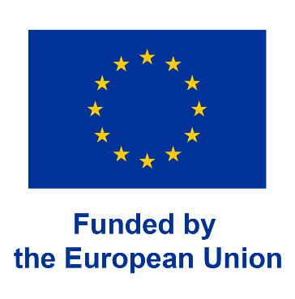
Funded by the European Union. Views and opinions expressed are however those of the author(s) only and do not necessarily reflect those of the European Union. Neither the European Union nor the granting authority can be held responsible for them.

