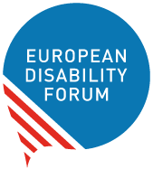

Events Checklist:
Making campaign events accessible for persons with disabilities
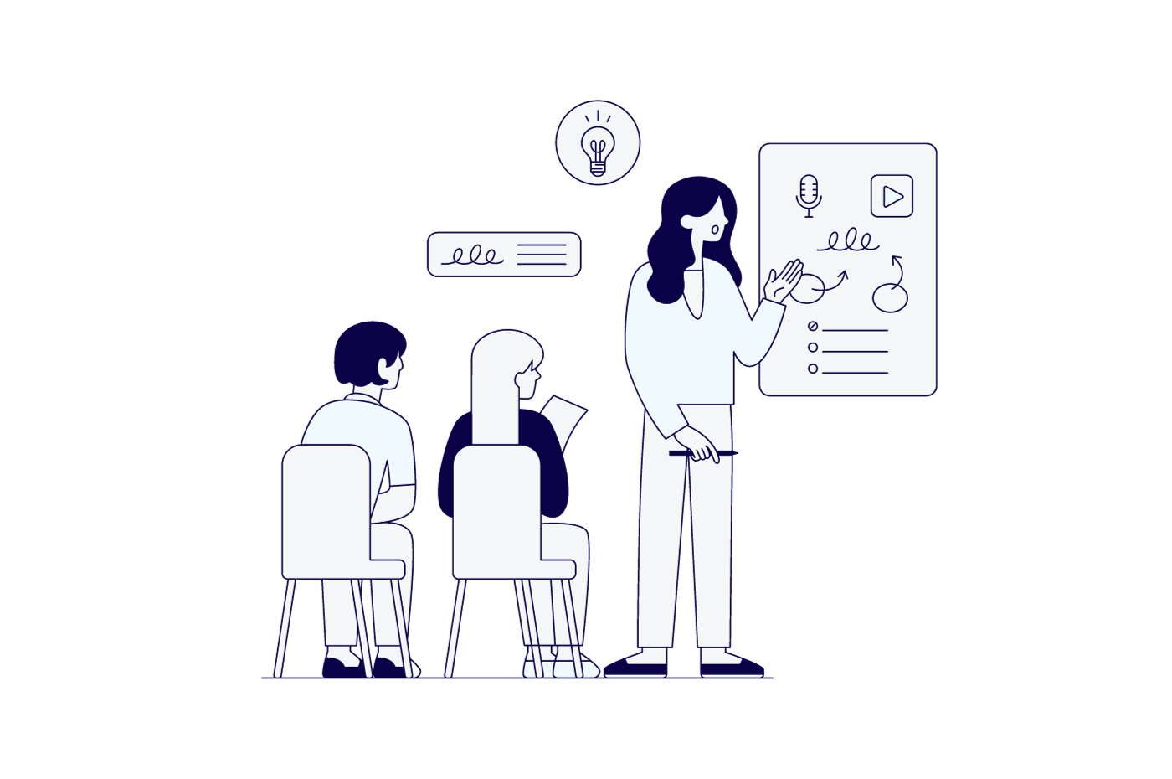

Funded by the European Union. Views and opinions expressed are however those of the author(s) only and do not necessarily reflect those of the European Union. Neither the European Union nor the granting authority can be held responsible for them.

Table of Contents

Introduction 3
Presentations 4
Learn 4
Online events and webinars 5
Learn 5
In-person Events 6
Learn 7
Scoring 8
Presentations 8
Online events and webinars 8
In-person Events 9
Results 9
From 0 to 30 points: novice 10
From 30 to 90 points: organiser 10
From 90 to 113 points: expert 10
From 113 to 126 points: maven 10
Document credits 11

Introduction
Over 87 million persons with disabilities live in the European Union. However, most election campaigns still do not consider their accessibility needs.
Persons with disabilities are often deprived of their right to stand as a candidate and to cast an informed vote due to accessibility barriers in all parts of the electoral process – including in fully participating in events from political parties.
This checklist is intended to provide persons working in elections and political campaigns with an easy-to-check and implement process to ensure that their events are inclusive of and for persons with disabilities.
The checklist is divided into three sections: in-person events, online events and how speakers should present accessibly. This way, the reader can easily take steps to ensure their events can include everyone.
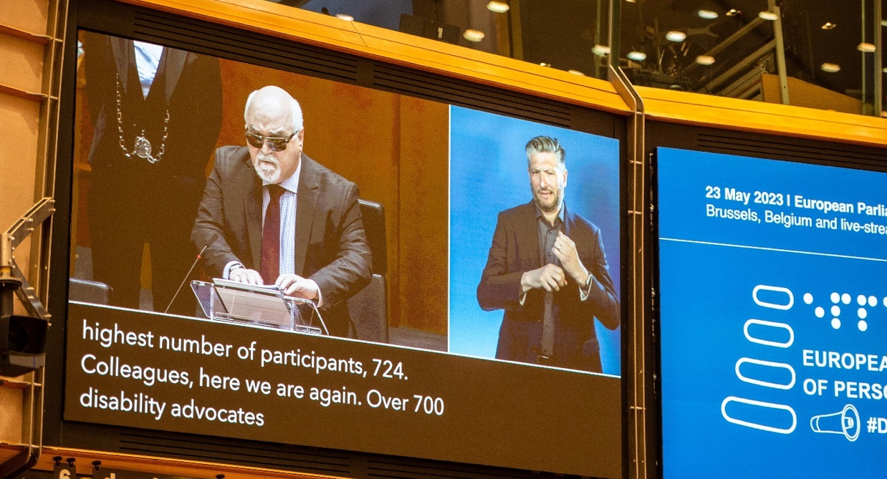

The European Parliament of Persons with Disabilities strived for accessibility. Credits: Michael Chia

Presentations
- ☐ I have visual support when doing a presentation (even if it’s just keywords on a slide)
- ☐ My visual support has text with a sans-serif font with a size of at least 28.
- ☐ I describe visual content.
- ☐ I speak slowly.
- ☐ I stop speaking and repeat if someone asks.
- ☐ I have a small summary of my points at the end of my presentation.

Learn
- Learn about accessible presentations with EDF Accessible PowerPoint presentations.

Online events and webinars
- ☐ I provide real time captioning.
- ☐ I provide sign language interpretation.
- ☐ I informed real-time captioners and interpreters of the attendees who requested these measures.
- ☐ I make available documents used in the event in advance accessible formats.
- ☐ I provide documents in easy-to-read upon request.
- ☐ If am using supporting files (video, documents, written speech, presentation, etc.) I share them with interpreters, captioners and participants ahead of the event.
- ☐ My event takes less than 2 hours and 30 minutes.
- ☐ My event has, at least, a 10-minute break.
- ☐ The invitation to my event is accessible.
- ☐ The invitations clearly state foreseen accessibility features (e.g. live subtitles, sign language interpretation, others…).
- ☐ The registration form is accessible, or a built-in form (for example when using Zoom).
- ☐ I added a question in the registration form about accessibility features.
- ☐ I explain accessibility features, and how to use the different features of the online meeting in the first minutes of my event.
- ☐ I asked the speakers to speak slowly and turn on the video (if possible).
- ☐ I asked the speakers to describe visual content.
- ☐ If I am using breakout rooms, I ensure all attendees who need it have access to accessibility features.
- ☐ If it’s an interactive event, I am providing alternative formats for participants to communicate (written chat, voice, etc).
- ☐ I request feedback about the event and accessibility features after it ends.
- ☐ All third-party software I use for interactive polls or activities is accessible.

Learn
- Learn about platform accessibility and how to make your event accessible on our toolkit for accessible meetings.

In-person Events
- ☐ I clearly state the accessibility provisions of my event during its promotion.
- ☐ I ask information about accessibility needs on my registration form.
- ☐ I make available a contact point to request information or accessibility provisions (if there is no registration form).
- ☐ I provide sign language interpretation.
- ☐ I provide real-time captioning, and, if possible, an additional screen for it.
- ☐ I make available documents used in the event in advance accessible formats.
- ☐ The sessions are a maximum of 90 minutes long, with 20 minutes break between.
- ☐ I provide documents in Braille and large text upon request.
- ☐ I provide documents in easy-to-read upon request.
- ☐ My venue is accessible: it has accessible parking spaces.
- ☐ My venue is accessible: it has accessible toilets.
- ☐ My venue is wheelchair-accessible: there are no stairs, or there are lifts and/or ramps at least 90cm wide and with a maximum 5% slope).
- ☐ My venue is wheelchair-accessible: doors are at least 85cm wide (sliding doors: 110 cm) .
- ☐ My venue is accessible: it has an induction loop.
- ☐ My venue is accessible: if there are lifts, they have audio and light signals to indicate floors; indicate which lift arrived at a floor.
- ☐ My venue, including common areas, is accessible:if there are lifts, they are large enough to accommodate wheelchair users. They have adequate lighting, a mirror and a support bar.
- ☐ My venue is accessible: if there are lifts, lift buttons have braille and are installed between 80 and 120 cm high so wheelchair users can use it.
- ☐ I provide hearing loops during events.
- ☐ My meeting room has a podium with a ramp or no podium.
- ☐ I have a help desk, or someone to help participants is easily identifiable.
- ☐ I provide participants with an easy way to ask speakers to speak slower (example coloured or differently shaped cards).
- ☐ Speakers speak slowly and have a microphone to speak to.
- ☐ If participants speak, I ensure they use a microphone.

- ☐ I ensure there is assistance to hold the microphone if needed.
- ☐ I ensure that possible allergens are clearly marked during food breaks.
- ☐ I ensure chairs and lower tables are available during breaks.
- ☐ If I am providing transport, I ensure there is accessible transport available.
- ☐ If I am providing accommodation, I ensure persons have the necessary accessibility measures.
- ☐ I make available emergency-related information in accessible formats or I explain at the beginning of the event.

Learn
- The EDF guide for accessible meetings provides a detailed explanation on the requirements for your in-person event.

Scoring
When scoring, check each section. If you ticked the box, count the correspondent points below. The points represent a balance between their usefulness and difficult to implement.

Presentations
Number 1 : 2 points
Number 2 : 1 point
Number 3 : 1 point
Number 4 : 2 points
Number 5: 3 points
Number 6: 3 points
Number 7: 2 points
Total: / 14

Online events and webinars
Number 1: 3 points
Number 2: 3 points
Number 3: 2 points
Number 4: 1 point
Number 5: 3 points
Number 6: 2 points
Number 7: 3 points
Number 8: 2 points
Number 9: 2 points
Number 10: 2 points
Number 11: 2 points
Number 12: 2 points
Number 13: 2 points
Number 14: 3 points
Number 15: 3 points
Number 16: 2 points
Number 17: 3 points
Total: /40

In-person Events
Number 1 : 2 points
Number 2 : 2 points
Number 3 : 2 points
Number 4 : 3 points
Number 5: 3 points
Number 6: 2 points
Number 7: 2 points
Number 8: 3 points
Number 9: 3 points
Number 10: 2 points
Number 11: 3 points
Number 12: 3 points
Number 13: 3 points
Number 14: 3 points
Number 15: 3 points
Number 16: 3 points
Number 17: 3 points
Number 18: 3 points
Number 19: 2 points
Number 20: 2 points
Number 21: 3 points
Number 22: 2 points
Number 23: 3 points
Number 24: 3 points
Number 25: 3 points
Number 26: 3 points
Number 27: 3 points
Number 28: 3 points
Number 29: 2 points
Total: / 77

Results
Added total: : /131
Added the totals, and check where you score at organising accessible events.

From 0 to 30 points: novice
You just started to learn to how to do accessible events. You might know the basics, but you still need experience applying them.

From 30 to 90 points: organiser
It’s not your first accessible event. You have been learning and are progressively applying. Some persons with disabilities are able to fully participate, but you still must improve.

From 90 to 113 points: expert
You have some experience. You have checked with persons with disabilities, and are able to accommodate most people. You still get it wrong here and there – or don’t have enough resources to implement everything – but your events started to become an example.

From 113 to 126 points: maven
Congratulations! You know what people need and are able to provide. You do everything you can to prepare. Almost everyone can attend your events.
It is important to remember that each person with disabilities as very different needs, so this checklist might not be enough to do an event that is completely accessible for all, but you sure are doing your very best!

Document credits
- Editor: André Felix, EDF Communications Coordinator
- Contributors: Raquel Riaza, EDF Events Coordinator
- Design: Natalia Suaréz, EDF Senior Communications Officer

The European Disability Forum
Mundo Madou
Avenue des Arts 7-8
1210 Brussels, Belgium.
www.edf-feph.org
info@edf-feph.org

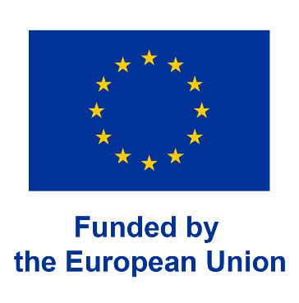
Funded by the European Union. Views and opinions expressed are however those of the author(s) only and do not necessarily reflect those of the European Union. Neither the European Union nor the granting authority can be held responsible for them.

